1D FEA

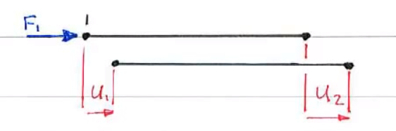

F1 in the positive direction when (u1-u2) > 0

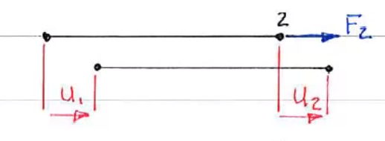

F2 in the positive direction when (u2-u1) > 0

Element stiffness matrix

